VMware Pro Cloud Service for Private Cloud Infrastructure - VMware VCF Automation Installation and Configuration Procedures 9.x

You can find the most up-to-date technical documentation on the VMware website at:
https://docs.vmware.com/
Broadcom®
3421 Hillview Ave.
Palo Alto, CA 94304
www.vmware.com
Copyright© 2026 Broadcom® All rights reserved. Copyright and trademark information.
Contents
1. Purpose and Assumptions 4
VMware Products and Versions 4
Architecture Model 4
2. Installation and Configuration Procedures 6
Deploy Additional VCF Automation Instances into an Existing VCF Fleet 6
3. References 10
References 10

Purpose and Assumptions
This document provides step-by-step instructions for installing, configuring and deploying the solution for Customer.
This document is written with the assumption that the administrator who uses these procedures is familiar with the products being used. It is not intended for administrators without prior knowledge of the concepts and terminology.

VMware Products and Versions
The following table lists the product versions used in this service. The build numbers here refer to the downloaded installer version of this guide.
Table 1-1. VMware Products and Versions
VMware Product | Version Number
VMware Cloud Foundation | 9.0.1.0 Build 24965341
The Private Cloud Automation for VMware Cloud Foundation VMware Validated Solution recommends the following bill of materials for the VCF Automation Deployment.
Table 1-2. Cloud Foundation Installed Products and Versions
VMware Product | Version Number
VMware VCF Automation | 9.0.1.0 Build 24965341
VMware VCF Operations orchestrator | 9.0.1.0 Build 24923009
- You can use Fleet Management to deploy VCF Automation, VCF Operations for Logs and VCF Operations for Network.

Architecture Model
Standardization of software configuration which improves predictability, supportability and speed of delivery. Considering these benefits, VMware has developed VMware Cloud Foundation.
VMware Cloud foundation brings a comprehensive design to an environment that covers everything from hardware configuration to automated software installation and configuration of the entire SDDC. The result is a highly available, scalable and robust platform, that is vigorously tested.
VMware Cloud foundation uses its own customized architecture and adds on VMware Validated Solutions to add functionality as appropriate. This service uses these different architectures as a baseline for deployment.
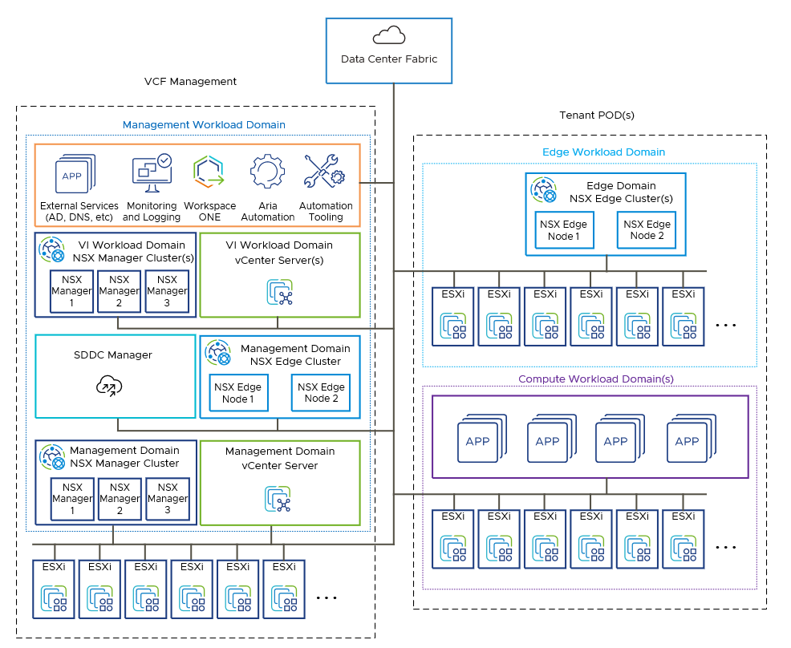

Installation and Configuration Procedures
This section provides step-by-step procedures for common configuration tasks to be performed during the deployment of the product in Customer's environment.

Deploy Additional VCF Automation Instances into an Existing VCF Fleet
VCF Management supports multiple instances of VCF Automation. After you deploy your first VCF Automation instance into VCF Operations 9.0, you can deploy additional VCF Automation instances into your existing fleet.
The first instance of VCF Automation that you import or deploy is integrated with VCF Operations. See Import and Upgrade VMware Aria Automation in VCF Operations 9.0. Any additional VCF Automation deployments are classified as non-integrated components. VCF Automation 9.0 is the only component that can run in non-integrated mode with VCF Operations.
To better understand the features available when VCF Automation is deployed with VCF Operations in integrated or non-integrated mode, refer to the following table.
Table 2-3. VCF Automation in Integrated vs Non-Integrated mode
Feature | Integrated mode | Non-integrated mode
Perform certificate and password management for VCF Automation using the VCF Operations UI | Available | Not available
Integrate VCF Automation with VCF SSO using VCF Operations | Available | Not available
Perform all Day-N operations for VCF Automation such as backup and restore, NTP changes, Power on and off. | Available | Available
Ability to push service accounts and capabilities from VCF Automation to VCF Operations | Available | Not available
Integration of VCF Automation with VCF Operations for Logs | Available | Not available
For example, if you have production, development, and testing instances of VCF Automation , you might choose to deploy the production instance in integrated mode first, then deploy development or testing instances in non-integrated mode.
Note If the first deployment is in the drafted or failed state when a second deployment is triggered, the second deployment will always be a non-integrated component.
To add non-integrated VCF Automation instances, perform the following steps.
Prerequisites
- Download the install binaries for VCF Automation from Binary Management. See Downloading VCF management components.
- Verify that you have an existing VCF fleet.
Procedure
- On the Overview tab, click ADD to deploy VCF Automation .
- Select the options for your deployment.
  - Installation type
NEW | Deploys a new component. If selected, you will be able to choose a different profile for the deployment.
IMPORT | Import a component that was removed from fleet management appliance for troubleshooting purposes post deployment.
IMPORT from Legacy Fleet Management | Import a 8.x component from VMware Aria Suite Lifecycle , specifically for brownfield customers.
  - Version: 9.0 (default)
  - Deployment Type: To choose the correct type, click View Sizing Info and review the compute nodes and resources that a Small, Medium, or Large deployment supports. See Sizing guidelines for VCF Automation.
- If you select NEW, click + to create a certificate:
  - Enter an FQDN
  - The Common Name and a Subject Alternative Name must include the FQDN
- Enter the Infrastructure properties.
  - For vCenter, select the Management Domain vCenter
  - Enter information for the primary cluster.
    - Cluster
    - Folder
    - Resource Pool
    - Network
    - Datastore
- Enter the Network properties.
  - Domain Name: Top-level domain, such as example.com.
  - Domain Search Path: Top-level domain, such as example.com.
  - DNS Servers: To select the DNS server that you want to configure VCF Automation with, click Edit Server Selection. If the DNS server that you want is not available, click Add New Server to add and select it.
  - NTP: To select the NTP server that you want to VCF Automation with, click Edit Server Selection. If the NTP server that you want is not available, click Add New Server to add and select it.
  - IPv4 Details:
    - IPv4 gateway: Default gateway of the network for VCF Automation to join.
    - IPv4 netmask: Netmask of the network for VCF Automation to join.
- Enter the Component information.
Component Properties
  - FQDN -- Enter the component FQDN
  - Certificate is prepopulated with the value from the previously added or selected certificate.
If you do not want to use the prepopulated certificate, click Add Certificate to create a new one.
  - Component Password -- Select one component password for two accounts:
    - vmware-system-user
    - Provider's admin account
If you do not have a password, click Add Password to create a new one. Password must be a minimum of 15 characters.
Cluster VIP
  - Choose internal or external load balancer:
    - For internal load balancer, the FQDN should resolve to the primary VIP address.
    - For an external load balancer or others, the FQDN should resolve to the Virtual Server IP address of the load balancer.
Components
  - VM Node Prefix: A unique identifier used to name component nodes. To avoid conflicts and maintain proper node identification within the cluster, ensure that the node prefix is unique.
  - Internal Cluster CIDR: IP Address range used for internal cluster communication within the cluster. Choose a range that does not conflict with existing networks in infrastructure
  - Primary VIP: The Primary Virtual IP Address is used for accessing component services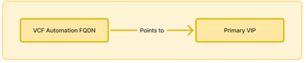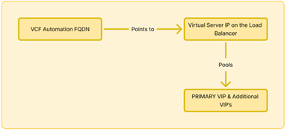
    - Figure 2-1. Primary VIP if using internal load balancer
    - Figure 2-2. Primary VIP if using external load balancer
  - Additional VIP's: This is optional. Depending on the small, medium, or large deployment type, you may add up to two additional VIPs.
  - VM Node Prefix: Unique identifier used to name component nodes. Ensure this prefix is distinct for a cluster to avoid conflicts and maintain proper node identification
  - Cluster Node IP Pool: The Node IP Pool is a range of IP addresses allocated to cluster nodes. These IP's ensure that each node has a unique address for internal communication within the cluster. Additional IP's from the pool will be used during rolling cluster upgrades. The pool must contain a minimum of four IP addresses.
- Precheck: Click Run Precheck.
- Summary: To trigger the deployment after reviewing the summary, click Submit.

References
The following section lists the documentation resources which were used for this document.

References
For more information, see the following supplemental configuration and administration guides, white papers and best practices documents.

VMware Pro Cloud Services for Private Cloud Solution References
Remember Refine or add any additional links to product documentation
See the VMware Cloud Foundation Documentation (https://techdocs.broadcom.com/us/en/vmware-cis/vcf/vcf-9-0-and-later/9-0.html) for product documentation for Cloud Foundation.
The information is arranged by topics that include the following:
- VMware Cloud Foundation 9.0 Release Notes
- VMware Cloud Foundation Planning and Preparation Workbook
- VMware Cloud Foundation Design Guide
- VMware Cloud Foundation Deployment, Convergence and Upgrade Guide
- VMware Cloud Foundation Building Cloud Infrastructure Guide
- VMware Cloud Foundation vSphere Guide
- VMware Cloud Foundation vSAN Guide
- VMware Cloud Foundation NSX Guide
- VMware Cloud Foundation Lifecycle Management Guide
- VMware Cloud Foundation Fleet Management Guide
- VMware Cloud Foundation Infrastructure Operations Guide
- VMware Cloud Foundation Workload Monitoring and Observability Guide
- VMware Cloud Foundation vSphere Supervisor Platform Guide
- VMware Cloud Foundation Security and Compliance Guide
- VMware Cloud Foundation API Reference Guide
VMware Validated Solutions Guides:
- <Add as apporpriate>

